**515. Find Largest Value in Each Tree Row**

Medium

121471Add to ListShare

Given the root of a binary tree, return *an array of the largest value in each row* of the tree **(0-indexed)**.

**Example 1:**

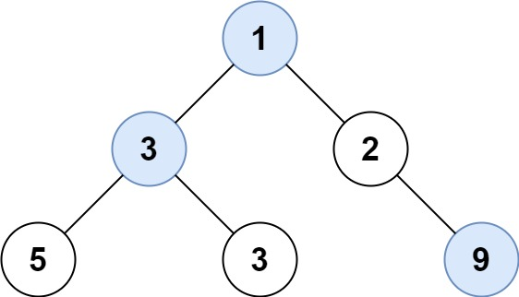

**Input:** root = [1,3,2,5,3,null,9]

**Output:** [1,3,9]

**Example 2:**

**Input:** root = [1,2,3]

**Output:** [1,3]

**Example 3:**

**Input:** root = [1]

**Output:** [1]

**Example 4:**

**Input:** root = [1,null,2]

**Output:** [1,2]

**Example 5:**

**Input:** root = []

**Output:** []

**Constraints:**

* The number of nodes in the tree will be in the range [0, 104].
* -231 <= Node.val <= 231 - 1

Accepted

126,952

Submissions

204,185